CONSIDERING THE LUDICROUS!!!

TEXT DIVIDED INTO CHUNKS | Why the statements could be true. | Why the statements are ludicrous | LUDICROUS OR JUSTIFIABLE?
A spacesuit protects astronauts from heat and cold and gives them air to breathe. The helmet protects their eyes from the sun. | Space suits are supposed to protect the body. This suit protects the body. | Space suits protect the body in space. This suit would not protect a person in space. |  | This is a space suit.
In the space station astronauts wear jeans or shorts and a T-shirt. They wear the same clothes for days because they can't wash their clothes in space!! | Most astronauts wear jeans or shorts and a t-shirt in space. Maybe some have a sense of humour and wear a pirate costume. | Astronauts wear jeans in space, not pirate costumes. | 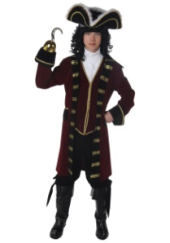 | This is what astronauts wear when they take off their space suits.
Astronauts live in space stations for more than a year. Space stations protect the astronauts from zero oxygen in space. | Space stations protect astronauts from zero oxygen in space. This protects people from zero oxygen in the ocean. | Space stations are in space. This is a submarine. A submarine is made for the water. It cannot fly. | 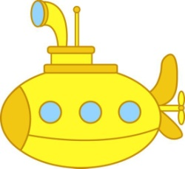 | This is a space station.

