CONSIDERING THE LUDICROUS

CHUNKS OF TEXT | Why the statement could be true | Why the statement is ludicrous | Image and Statement
The culinary arts industry is quickly becoming a respected occupation. There is an increasing demand for skilled employees, not only for highly trained chefs. Educational facilities can be utilized to showcase the work that is being accomplished and the progress of the students, or community cooperation can be of a different nature. | A highly-trained motorcycle enthusiast might be confident enough to wear a chef's hat. | Motorcycle enthusiasts wear helmets that protect their heads and make them look fierce. | 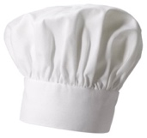  This is the type of headgear a  highly-trained motorcycle  enthusiast wears.
The practical skills of a culinarian (food service professional) is very specific. A culinarian needs to be able to do math in order to convert measurements, a sense of history in order to establish food origin, and spice sense to compliment food of particular regions, | It's possible to use spices to spices to do mathematical conversions in measurements if we use different containers. | Even though different countries have special ways to calculate mathematical conversions, spices are powders and cannot be used independently as an accurate way of doing this. | 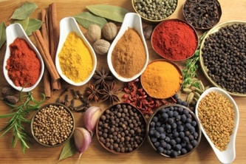  These spices are used to  mathematically  calculate conversions in  measurements.
The history of food has cross-cultural roots that can provide the framework for individual leadership opportunities. Each student can help organise with the assistance of the culinary educator, a menu that is based on his or her culture or family traditions. | Some students need someone very confident and direct. A dictator could be the ideal person for these types of students. | A dictator might find having power on one kitchen a very small domain. | This is the ideal culinary educator to  help students to organise a menu  based on their cultural traditions.

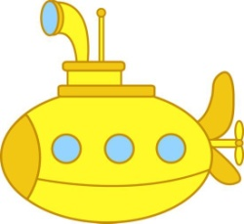
LUDICROUS or a bit of TRUTH?
NEGOTIATE and JUSTIFY your conclusions!
scaffoldingmagic.com
This is a space station.
This is a spacesuit.

