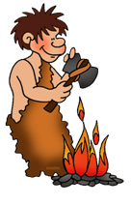

Prehistory begins when humans first became organised and wore clothes.

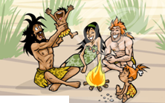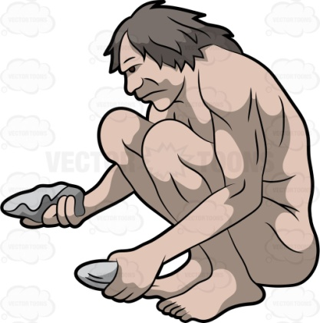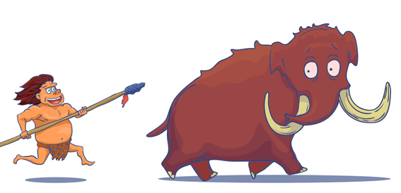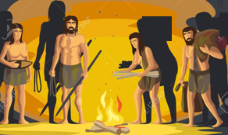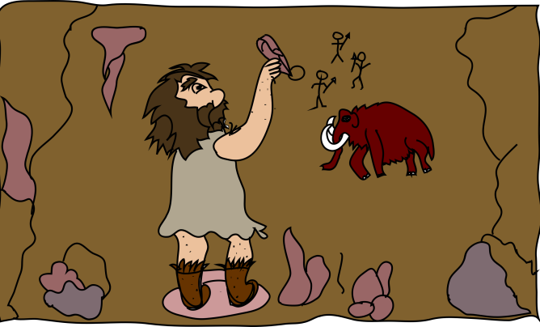

scaffoldingmagic.com

Hunters in pre-history used rocks to hunt, fish and to make their clothes.

Humans in pre-history were nomads, which means that they did not have one specific place where they lived. They moved frequently.

Humans in prehistory lived in tribes.

Humans lived together, hunted, collected fruit, and depended on nature.

They painted works of art on the walls of their caves.

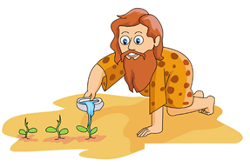

After thousands of years, humans in pre-history discovered that they could plant seeds, and water the plants to cultivate food.

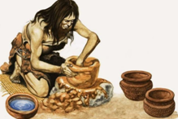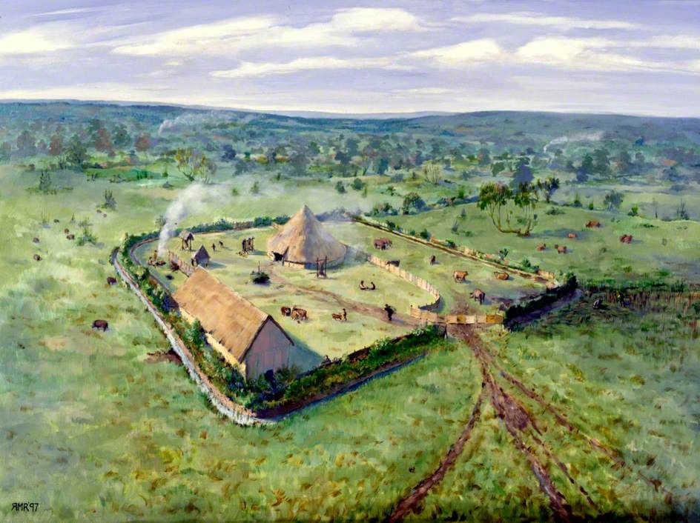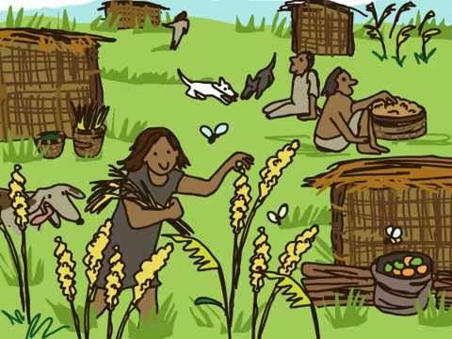

scaffoldingmagic.com

We know things about the first human populations by studying the metal and ceramic objects they made.

Humans became sedentary, which means, they built closed communities where they kept their houses, animals, and farms.

They also learned to make fences and take care of animals, so they didn't have to hunt. They could stay in the same place and not be nomads.