
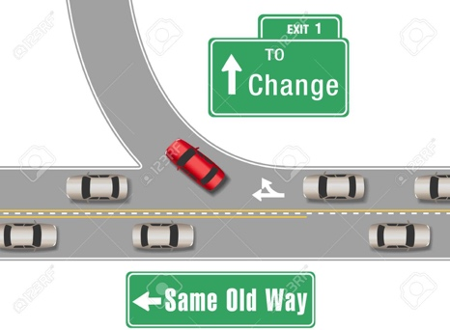
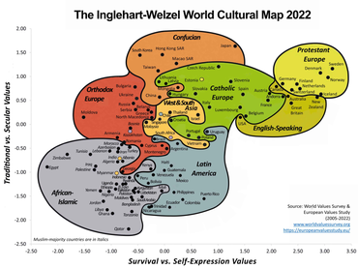
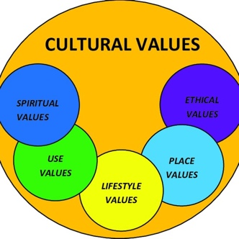
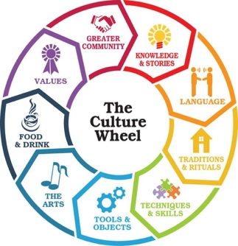
https://essaysservice.com/essays/sociology/deculturalization-and-america/

Just as there are countless number of cultures in the world so there are methods of deculturization. These methods most of which have contributed to the erosion of culture in the United States include change of language, segregation and isolation.

Like any other culture in the world, American culture is defined by and not limited to language, religion, dressing, music and food. Therefore, deculturization occurs when individuals or the whole society abandons its culture or deviates from its original cultural standards.

It is important to mention that culture is wide and universal, it is not unique. There are many communities in the world which share practices and beliefs thus being defined by similar life boundaries. Political scientists Ronald Inglehart and Christian Wetzel have spent years studying international values of cultures.

Notably, many misfits in the society are as a result of being decultured. What is culture? Sociologists define culture in various ways. It can be described as a set of common values practices, goals and attitudes which define a society institution or nation.

Deculturization can only be described and comprehensively understood by grasping the underlying meaning of culture. It is very easy to know when one becomes decultured by looking at the level of deviation from normally acceptable behavior and practices.

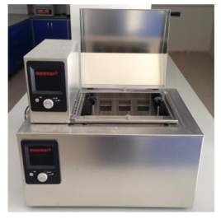
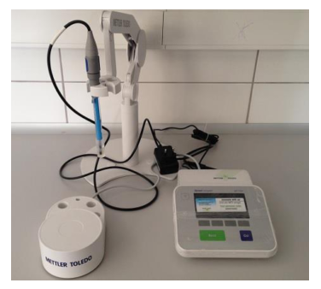
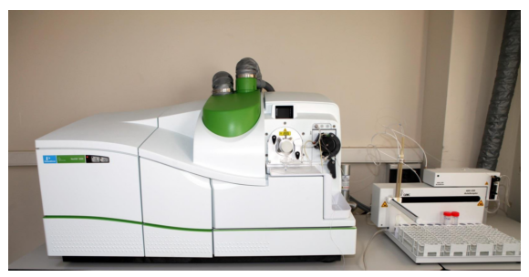

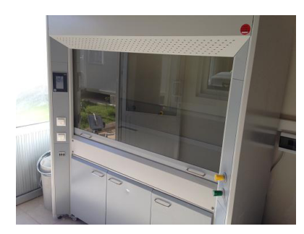
This is an air lifting cabinet in which toxic gas or fragrance-releasing reactions during solution preparation and use, as well as chemical processes, are performed, and which provides the safe discharge of environmentally harmful gasses.
When filled with water, this machine is used to adjust the temperature, and maintains solution and mixture samples in containers, such as glass tubes, glass bottles, beakers, flasks, etc., at a constant temperature during an experiment.
This machine is used to determine the pH balance of a solution prior to experiments, and to monitor the Ph value during experiments.
This is a machine used for chemical analysis that produces quick, inexpensive, precise and accurate qualitative, quantitative or semi-quantitative measurement of a multitude of elements in solid or liquid form.
This is used for heating, baking or drying purposes with different settings. The temperature can be adjusted from 60º-250º by analog or digital thermostats.

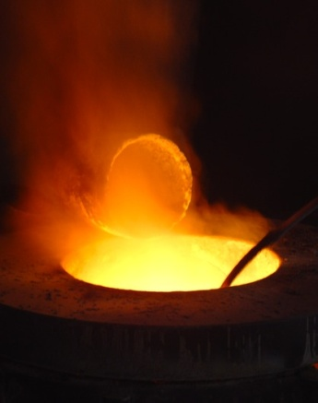

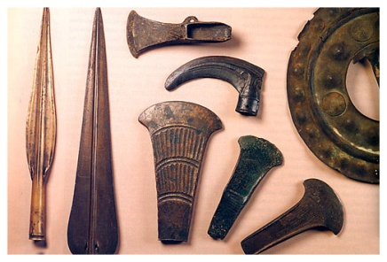
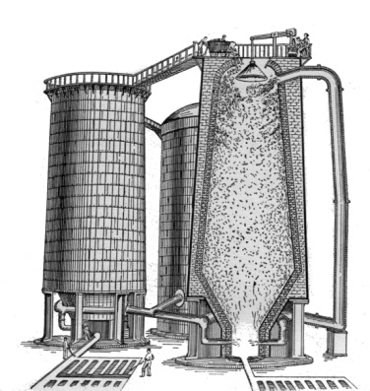

First Industrial Revolution: bronze progressively elevated the quality of life on the planet both in art, shipping, irrigation and farming equipment, and weapons (unfortunately).
Third Industrial Revolution: production automation, information and Communications Technology, Internet, Digital (and the possibility of benefits to the environment according to Jeremy Rifkin).
First Industrial Revolution: 3,000 B.C.E. Mesopotamians mixed tin with other metals. When mixed with copper it created bronze, a metal stronger than any time known at that time, yet one that could still be cast into any shape.

Second Industrial Revolution (1870-1914): Began with the use of coke in blast furnaces, discovered by James Beaumont Neilson in 1828.

Fourth Industrial Revolution: Merging technologies in vast and varied fields. End result: vast unemployment in varied fields.

