SECONDARY - SOCIAL SCIENCE (RECYCLYING)

We can recycle old plastic to make ______ things. This is how we recycle plastic bottles. 1) We take plastic bottles to a recycling _______. 2) We take the bottles to a factory. 3) We break the bottles into _______ pieces. 4) We use the plastic pieces to make fibers. 5) We use the fibers to make T-shirts.

We can recycle old _______ to make new things. This is how we recycle plastic __________. 1) We take plastic bottles to a recycling center. 2) We take the bottles to a factory. 3) We ________ the bottles into small pieces. 4) We use the plastic pieces to make fibers. 5) We use the fibers to make T-shirts.

We can _______ old plastic to make new things. This is how we recycle plastic bottles. 1) We take plastic bottles to a recycling center. 2) We take the _______ to a factory. 3) We break the bottles into small pieces. 4) We use the plastic pieces to make fibers. 5) We use the ______ to make T-shirts.

We can recycle _______ plastic to make new things. This is how we recycle plastic bottles. 1) We take plastic bottles to a recycling center. 2) We _______ the bottles to a _______. 3) We break the bottles into small pieces. 4) We use the plastic pieces to make fibers. 5) We use the fibers to make T-shirts.

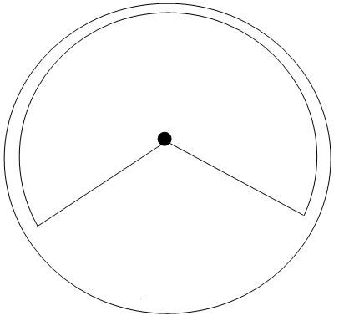

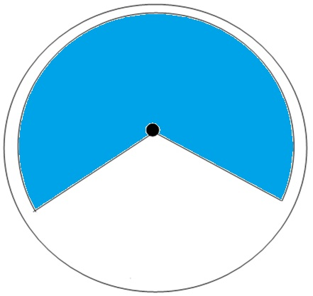

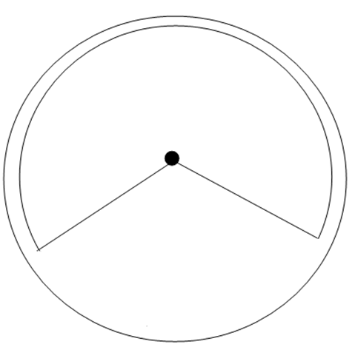

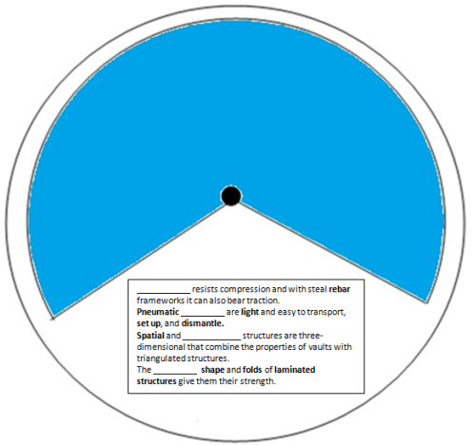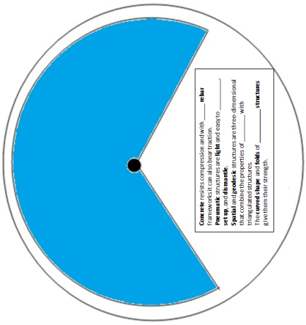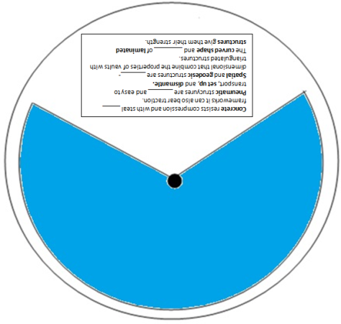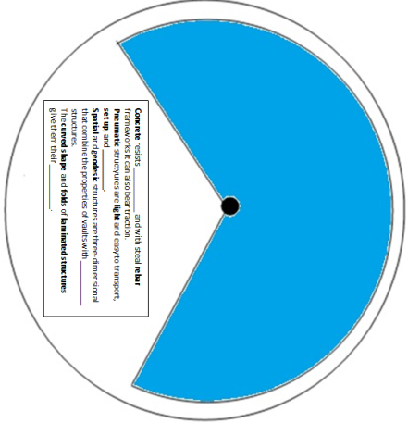

We can recycle old _______ to make new things. This is how we recycle plastic __________. 1) We take plastic bottles to a recycling center. 2) We take the bottles to a factory. 3) We ________ the bottles into small pieces. 4) We use the plastic pieces to make fibers. 5) We use the fibers to make T-shirts.

We can recycle old plastic to make ______ things. This is how we recycle plastic bottles. 1) We take plastic bottles to a recycling _______. 2) We take the bottles to a factory. 3) We break the bottles into _______ pieces. 4) We use the plastic pieces to make fibers. 5) We use the fibers to make T-shirts.



We can recycle _______ plastic to make new things. This is how we recycle plastic bottles. 1) We take plastic bottles to a recycling center. 2) We _______ the bottles to a _______. 3) We break the bottles into small pieces. 4) We use the plastic pieces to make fibers. 5) We use the fibers to make T-shirts.

We can _______ old plastic to make new things. This is how we recycle plastic bottles. 1) We take plastic bottles to a recycling center. 2) We take the _______ to a factory. 3) We break the bottles into small pieces. 4) We use the plastic pieces to make fibers. 5) We use the ______ to make T-shirts.

