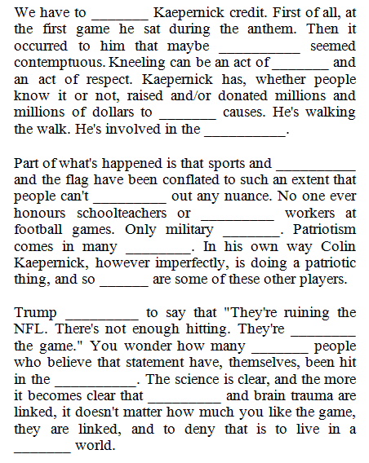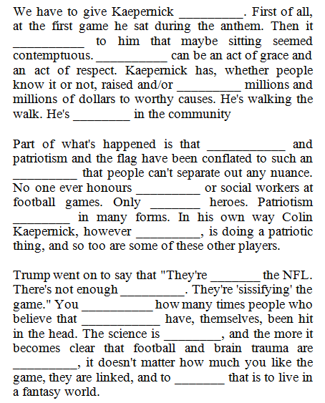

We _______ to give Kaepernick credit. First of all, at the first game he sat during the ________. Then it occurred to him that maybe sitting seemed ___________. Kneeling can be an act of grace and an act of ___________. Kaepernick has, whether people know it or not, raised and/or donated _______ and millions of dollars to worthy causes. He's ____________ the walk. He's ________ in the community

Part of what's happened is that sports and patriotism and the ________ have been conflated to such an extent that people _____ separate out any nuance. No one ever honours schoolteachers or social workers at football games. Only military heroes. Patriotism comes in ________ forms. In his own way Colin Kaepernick, ________ imperfectly, is doing a patriotic thing, and so too are some of these other players.

Trump went on to say _____ "They're ruining the NFL. There's not _______ hitting. They're 'sissifying' the game." You wonder how many times people who believe that statement have, themselves, been _____ in the head. The ________ is clear, and the more it becomes clear that _______ and brain trauma are linked, it doesn't matter how much you like the game, they are linked, and to deny that is to live in a fantasy ____________.

_____ have to give Kaepernick credit. First of all, at the first ________ he sat during the anthem. Then it occurred to him that _________ sitting seemed contemptuous. Kneeling can be an act of grace and an act of respect. Kaepernick has, whether people know it or not, raised and/or donated millions and millions of dollars to worthy _________. He's walking the _______. He's involved in the community

Part of what's happened is that sports and patriotism and the flag have been _______ to such an extent that people can't separate out any _________. No one ever ________ schoolteachers or social workers at football games. _______ military heroes. Patriotism comes in many forms. In his own way Colin Kaepernick, however imperfectly, is doing a patriotic thing, and so too are some of these other ___________.

Trump went on to ______ that "They're ruining the NFL. There's not enough hitting. They're 'sissifying' the ________." You wonder how many times people who ________ that statement have, themselves, been hit in the head. The science is clear, and the more it becomes clear that football and brain _______ are linked, it doesn't matter how much you like the game, they are linked, and to deny that is to _______ in a fantasy world.

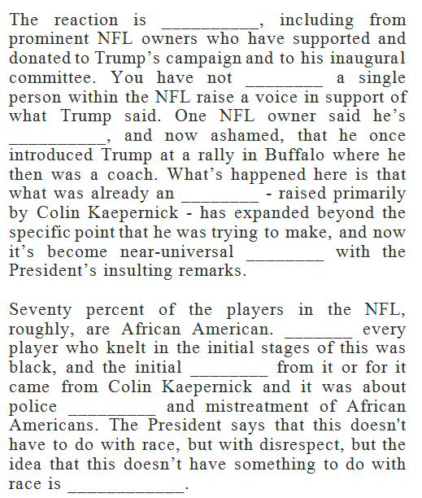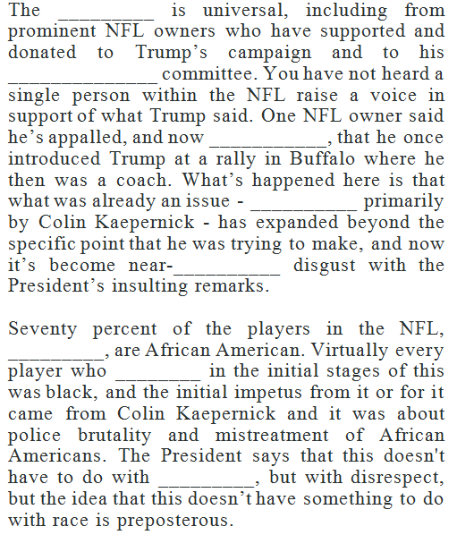

The reaction is universal, including from ____________ NFL owners who have supported and donated to Trump’s campaign and to his inaugural committee. You have not heard a single person within the NFL raise a _______ in support of what Trump said. One NFL owner said he’s appalled, and now ashamed, that he once introduced Trump at a ________ in Buffalo where he then was a coach. What’s happened here is that what was already an issue - raised primarily by Colin Kaepernick - has __________ beyond the specific point that he was trying to make, and now it’s become near-universal disgust with the President’s insulting remarks.

Seventy percent of the players in the NFL, roughly, are African American. Virtually every player who knelt in the initial ________ of this was black, and the initial impetus from it or for it came from Colin Kaepernick and it was about police brutality and mistreatment of African Americans. The President says that this doesn't have to do with race, but with __________, but the idea that this doesn’t have something to do with race is preposterous.

The reaction is universal, including from prominent NFL owners who have _________ and donated to Trump’s campaign and to his inaugural committee. You have not heard a single person _________ the NFL raise a voice in support of what Trump said. One NFL owner said he’s appalled, and now ashamed, that he once introduced Trump at a rally in Buffalo where he then was a ________. What’s happened here is that what was already an issue - raised primarily by Colin Kaepernick - has expanded beyond the specific point that he was trying to make, and now it’s become near-universal disgust with the President’s _________ remarks.

Seventy percent of the players in the NFL, roughly, are African American. Virtually every player who knelt in the initial stages of this was black, and the __________ impetus from it or for it came from Colin Kaepernick and it was about police brutality and mistreatment of African Americans. The President says that this doesn't have to do with race, but with disrespect, but the idea that this doesn’t have something to do with __________ is preposterous.