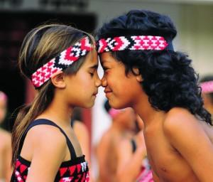

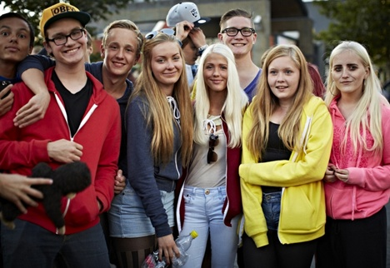

New Zealand

Maori child meeting a non-Maori child

I

1. What are the countries that border New Zealand?
2. What language is spoken in New Zealand?
3. What is the national animal, flag and song?
4. Show an image of the traditional clothes worn by people from New Zealand either in the present or in the past.
5. How long are winters in New Zealand and how long are the summers? What are the average temperatures in both seasons?

II If you were to meet Maori children in your classroom, how do you think they would answer the following questions:

1. What would you most want people to know about you?
2. When you feel happy, what do you do to show it?
3. How can you communicate with someone who doesn’t speak the same language you do?
4. If you saw someone in the street who was hurt, what would you do?
5. What is one thing people probably misunderstand about you?
6. How do you show that you care about someone else?

Iceland

Teenagers at a social event

I

1. What are the countries/bodies of water that border Iceland?
2. What language is spoken in Iceland?
3. What is the national animal, flag and song?
4. Show an image of the traditional clothes worn by people from Iceland either in the present or in the past.
5. How long are winters in Iceland and how long are the summers? What are the average temperatures in both seasons?

II If you were to meet teenagers from Iceland in your classroom, how do you think they would answer the following questions:

1. What would you most want people to know about you?
2. When you feel happy, what do you do to show it?
3. How can you communicate with someone who doesn’t speak the same language you do?
4. Do you feel isolated from other people in your country?
5. What is one thing people probably misunderstand about you?
6. How do you show that you care about someone else?

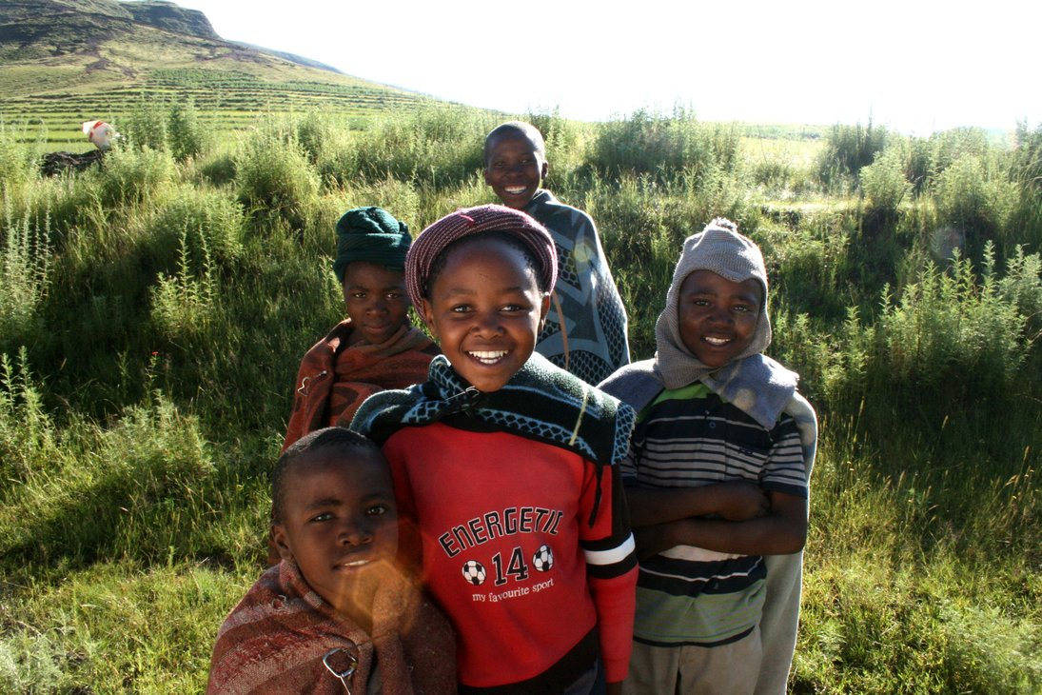

Lesotho

Children on a hike

I

1. What are the countries that border Lesotho?
2. What language is spoken in Lesotho?
3. What is the national animal, flag and song?
4. Show an image of the traditional clothes worn by people from Lesotho either in the present or in the past.
5. How long are winters in Lesotho and how long are the summers? What are the average temperatures in both seasons?

II If you were to meet children from Lesotho in your classroom, how do you think they would answer the following questions:

1. What would you most want people to know about you?
2. When you feel scared, how do you show it?
3. How can you communicate with someone who doesn’t speak the same language you do?
4. Do you feel isolated from other people in your country?
5. What is one thing people probably misunderstand about you?
6. How do you show that you care about someone else?

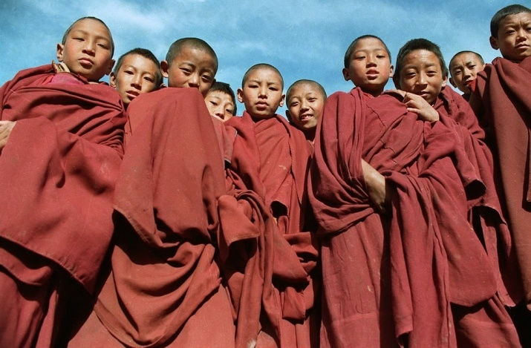

Tibet

Teenagers at their monastery

I

1. What are the countries that border Tibet?
2. What language is spoken in Tibet?
3. What is the national animal, flag and song?
4. Show an image of the traditional clothes worn by Tibetans either in the present or in the past.
5. How long are winters in Tibet and how long are the summers? What are the average temperatures in both seasons?

II If you were to meet children from Tibet in your classroom, how do you think they would answer the following questions:

1. What would you most want people to know about you?
2. When you feel scared, how do you show it?
3. How can you communicate with someone who doesn’t speak the same language you do?
4. What type of clothes do you most like to wear and why?
5. What is one thing people probably misunderstand about you?
6. How do you show that you care about someone else?

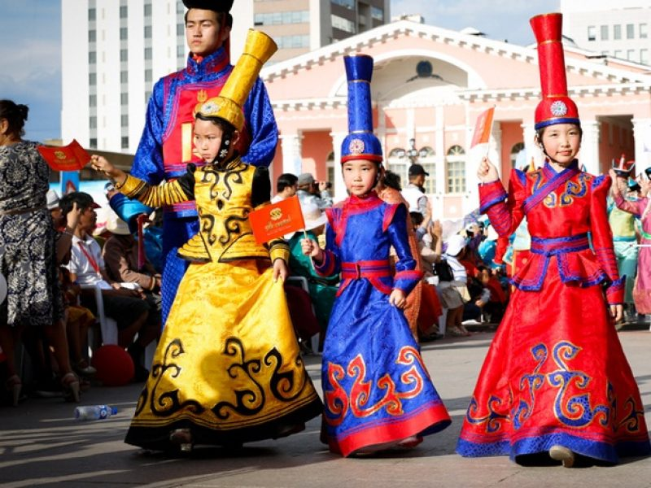

Mongolia

Mongolian children in traditional costume

I

1. What are the countries that border Mongolia?
2. What language is spoken in Mongolia?
3. What is the national animal, flag and song?
4. Show an image of the traditional clothes worn by Mongolians either in the present or in the past.
5. How long are winters in Mongolia and how long are the summers? What are the average temperatures in both seasons?

II If you were to meet children from Mongolia in your classroom, how do you think they would answer the following questions:

1. What would you most want people to know about you?
2. When you feel scared, how do you show it?
3. How can you communicate with someone who doesn’t speak the same language you do?
4. Would you rather live somewhere warm or somewhere cold?
5. What is one thing people probably misunderstand about you?
6. How do you show that you care about someone else?

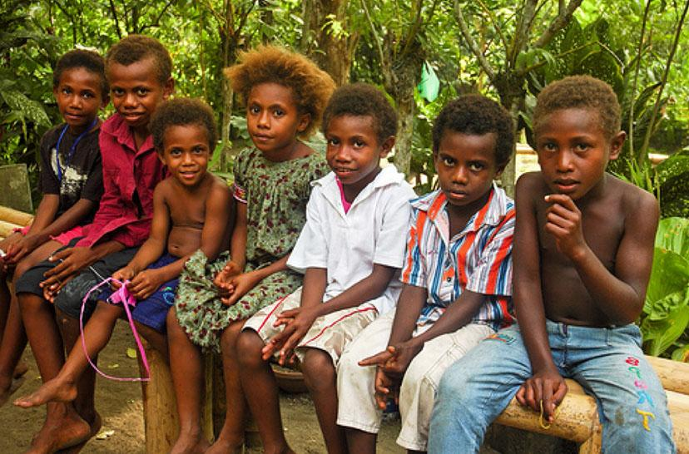

Papua New Guinea

Papau New Guinean children in a park

I

1. What are the countries that border Papua New Guinea?
2. What language is spoken in Papua New Guinea?
3. What is the national animal, flag and song?
4. Show an image of the traditional clothes worn by Papua New Guineans either in the present or in the past.
5. How long are winters in Papua New Guinea and how long are the summers? What are the average temperatures in both seasons?

II If you were to meet children from Papua New Guinea in your classroom, how do you think they would answer the following questions:

1. What would you most want people to know about you?
2. When you feel scared, how do you show it?
3. How can you communicate with someone who doesn’t speak the same language you do?
4. Would you rather live somewhere warm or somewhere cold?
5. What is one thing people probably misunderstand about you?
6. How do you show that you care about someone else?