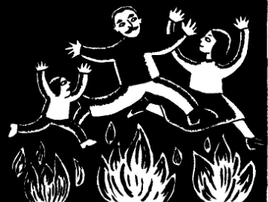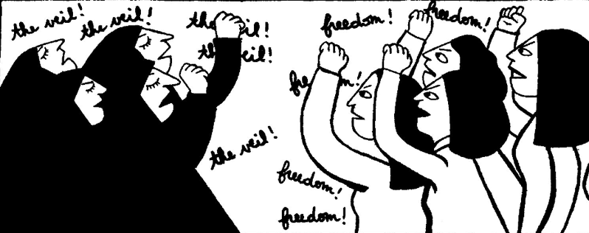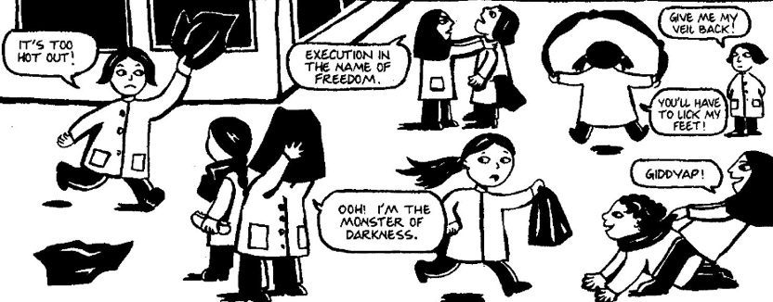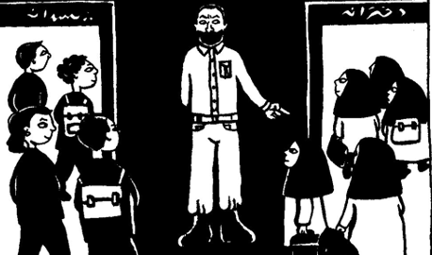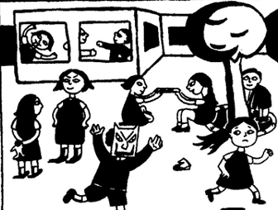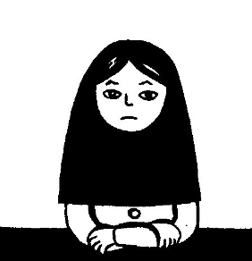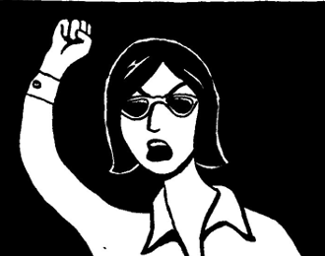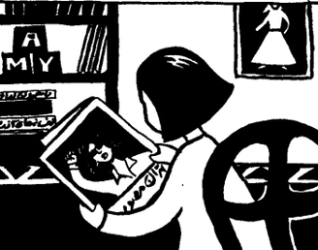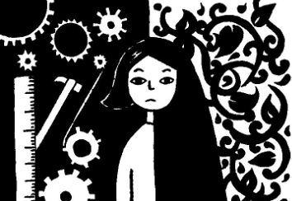

This is me when I was 10 years old.

In 1979 a revolution took place, and it became obligatory to wear a veil in school. We didn’t really like wearing a veil in school because we didn’t know why we had to.

The year before we were a French-religious school and boys and girls learned together.

Then suddenly, in 1980, boys and girls were separated, and we couldn’t learn in different languages.

Everywhere in the streets there were demonstrations against the new laws and especially against wearing veils.

At one of the demonstrations, a German reporter took a photo of my mother protesting the new laws.

I was very proud of her and her photo was published in all the European newspapers.

I really didn’t know what to think about all of this. Deep down I was religious, but my family was very modern and avant-garde.

I wanted to celebrate many different traditions like the Zarathustra holidays of the fire ceremony.