:

Exceptional Women in History

[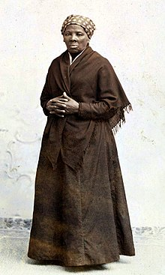](https://en.wikipedia.org/wiki/Harriet_Tubman#/media/File:Harriet_Tubman_by_Squyer,_NPG,_c1885.jpg)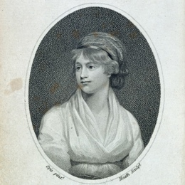[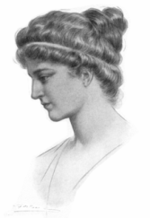](https://es.wikipedia.org/wiki/Hipatia#/media/File:Hypatia_portrait.png)

determination, dedication, fought against injustices, critical thinkers

**Hypatia**:

(350-415 A.C.E.)

Alexandria, Egypt

Raised by parents

mathematician philosopher astronomer

assassinated 415 A.C.E by Christians threatened by progressive ideas of Pagans

**Mary Wollstonecraft** (1759-1797)

writer, philosopher, advocate of women’s rights. One of the founding feminist philosophers and author of [A Vindication of the Rights of Women](https://en.wikipedia.org/wiki/A_Vindication_of_the_Rights_of_Woman).

**Harriet Tubman**

(1822-1913)

Parents: slaves

Born into slavery

abolitionist

humanitarian

spy

Women famous because of their admirable qualities.

Women famous because of their exposure in social media.

What values do they have in common?

What principles did they show to achieve their goals?

How did interpret their place in society and how did their actions oppose or appease that role?

How did they face adversity?

How are they different from you?

What if you had lived at the same time they did? Do you think you would have been friends with them? Explain.

**Malala Yousafzai**

(1997 - present)

activist for female education, and fights for human rights advocacy

**Li Qiaochu**

**(**1991 - present)

feminist, labour activist, currently detained for fight agaist gender violence

**Rosa Parks**

(1913-2005)

American activist, ‘Mother of the Freedom Movement’ for her pivotal role in the [Montgomery bus boycott](https://en.wikipedia.org/wiki/Montgomery_bus_boycott)

:

Exceptional Women in History

Women famous because of their admirable qualities.