**Scaffolding Reported Speech in Context**

***Handout***

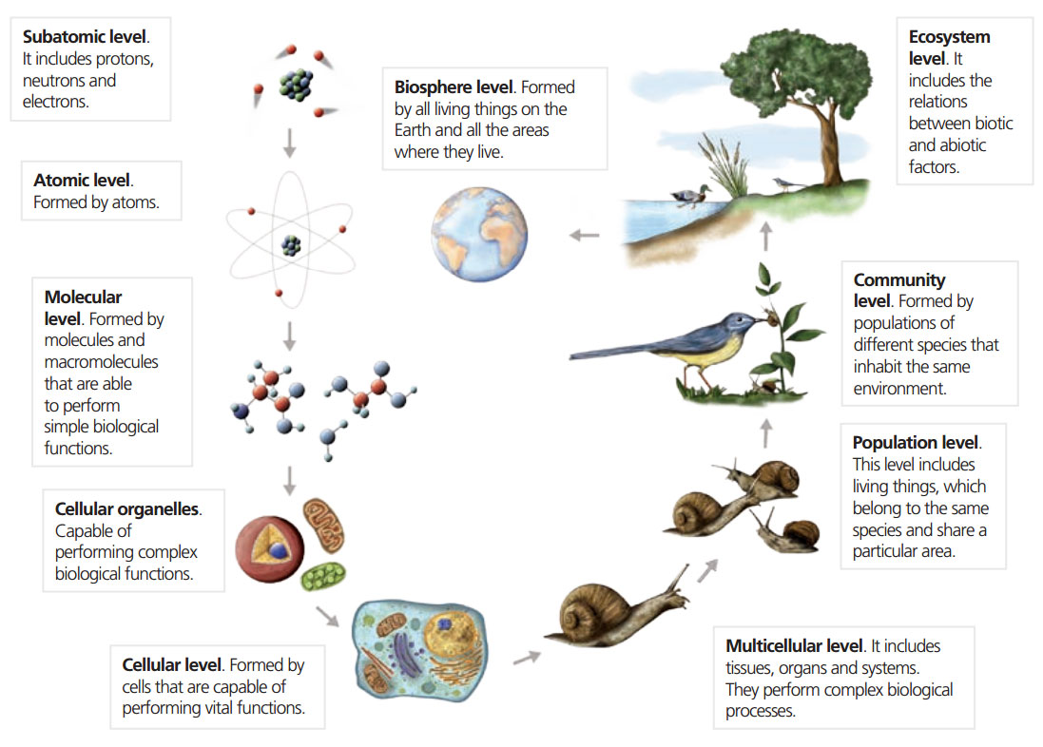

|  |  |
| --- | --- |
|  | Verbalising information |
|  | Cells ‘A subatomic level includes protons, neutrons and electrons.’ |
|  | Atoms ‘An atomic level is formed by atoms.’ |
|  | Molecules: ‘A molecular level is formed by molecules and macromolecules that are able to perform simple biological functions. |
|  | Etc. |

*Phrases to help to clarifications:*

*Could you repeat that, please?*

*What comes after…?*

*I didn’t hear…*

*One more time, please.*

*What did the ________ say?*

*Is that accurate?*

*Yes, that’s accurate.*

*No, that’s not accurate. I’ll repeat.*

*Well said.*

*Your turn.*