|  |  |  |
| --- | --- | --- |
| WORD | MEANING IN THIS SUBJECT | POSSIBLE SENTENCE USING THE WORD IN THIS SUBJECT |
| http://www.thirteen.org/edonline/nttidb/lessons/cb/1pixel.gifbitter | http://www.thirteen.org/edonline/nttidb/lessons/cb/1pixel.gifIn a bitter [argument](https://www.collinsdictionary.com/dictionary/english/argument) or [conflict](https://www.collinsdictionary.com/dictionary/english/conflict), people [argue](https://www.collinsdictionary.com/dictionary/english/argue) very angrily or [fight](https://www.collinsdictionary.com/dictionary/english/fight) very fiercely. | http://www.thirteen.org/edonline/nttidb/lessons/cb/1pixel.gifIt was the scene of bitter fighting during the Second World War. |
| commercialhttp://www.thirteen.org/edonline/nttidb/lessons/cb/1pixel.gif | http://www.thirteen.org/edonline/nttidb/lessons/cb/1pixel.gifCommercial [organizations](https://www.collinsdictionary.com/dictionary/english/organization) and [activities](https://www.collinsdictionary.com/dictionary/english/activity) are [concerned](https://www.collinsdictionary.com/dictionary/english/concern) with making [money](https://www.collinsdictionary.com/dictionary/english/money) or profits, [rather](https://www.collinsdictionary.com/dictionary/english/rather) than, for [example](https://www.collinsdictionary.com/dictionary/english/example), with [scientific](https://www.collinsdictionary.com/dictionary/english/scientific) [research](https://www.collinsdictionary.com/dictionary/english/research) or providing a [public](https://www.collinsdictionary.com/dictionary/english/public) [service](https://www.collinsdictionary.com/dictionary/english/service). | Whether the project will be a commercial success is still uncertain. |
| drivehttp://www.thirteen.org/edonline/nttidb/lessons/cb/1pixel.gif | To drive is to [push](https://www.collinsdictionary.com/dictionary/english/push), [propel](https://www.collinsdictionary.com/dictionary/english/propel), or be pushed or propelled | http://www.thirteen.org/edonline/nttidb/lessons/cb/1pixel.gifThe angry crowd was driven back by water guns. |
| fineshttp://www.thirteen.org/edonline/nttidb/lessons/cb/1pixel.gif | A fine is a [punishment](https://www.collinsdictionary.com/dictionary/english/punishment) in which a person is ordered to pay a sum of money because they have done something [illegal](https://www.collinsdictionary.com/dictionary/english/illegal) or broken a rule. | http://www.thirteen.org/edonline/nttidb/lessons/cb/1pixel.gifShe was *fined* 300€ and banned from driving for one month. |
| rightshttp://www.thirteen.org/edonline/nttidb/lessons/cb/1pixel.gif | http://www.thirteen.org/edonline/nttidb/lessons/cb/1pixel.gifRight is used to refer to activities or actions that are considered to be morally good and acceptable. | http://www.thirteen.org/edonline/nttidb/lessons/cb/1pixel.gifThe BBC thought it was right and proper not to show the film. |
| scaleshttp://www.thirteen.org/edonline/nttidb/lessons/cb/1pixel.gif | http://www.thirteen.org/edonline/nttidb/lessons/cb/1pixel.gifIf you [refer](https://www.collinsdictionary.com/dictionary/english/refer) to the scale of something, you are referring to its size or extent, [especially](https://www.collinsdictionary.com/dictionary/english/especially) when it is very [big](https://www.collinsdictionary.com/dictionary/english/big). | http://www.thirteen.org/edonline/nttidb/lessons/cb/1pixel.gifHowever, he underestimates the scale of the problem |
| http://www.thirteen.org/edonline/nttidb/lessons/cb/1pixel.gif... | http://www.thirteen.org/edonline/nttidb/lessons/cb/1pixel.gif | http://www.thirteen.org/edonline/nttidb/lessons/cb/1pixel.gif |
| http://www.thirteen.org/edonline/nttidb/lessons/cb/1pixel.gif... | http://www.thirteen.org/edonline/nttidb/lessons/cb/1pixel.gif | http://www.thirteen.org/edonline/nttidb/lessons/cb/1pixel.gif |
| http://www.thirteen.org/edonline/nttidb/lessons/cb/1pixel.gif... | http://www.thirteen.org/edonline/nttidb/lessons/cb/1pixel.gif | http://www.thirteen.org/edonline/nttidb/lessons/cb/1pixel.gif |

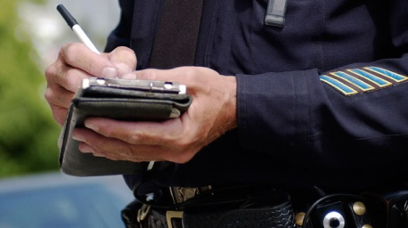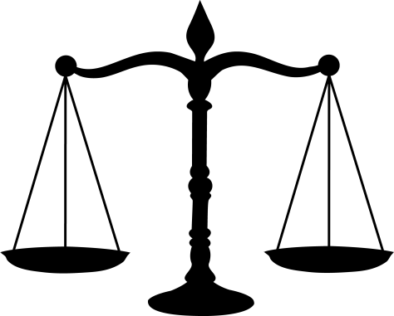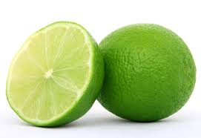

RIGHTS

FINE

SCALE

COMMERCIAL

BITTER

DRIVE