*A. Translate*:

aim _______________ lasting _______________ founders ________

culminate _______________ secure _______________

1. The European Union is set up with the aim of ending the frequent and bloody wars between neighbours, which culminated in the Second World War.
2. As of 1950, the European Coal and Steel Community begins to unite European countries economically and politically in order to secure lasting peace.
3. The six founders are Belgium, France, Germany, Italy, Luxembourg and the Netherlands. The 1950s are dominated by a Cold War between east and west.

B. Create a drum rhythm for one of the above sentences:

C. Write the number of the sentence that best represents image below

___ ___ ___

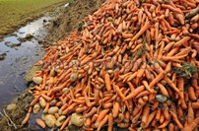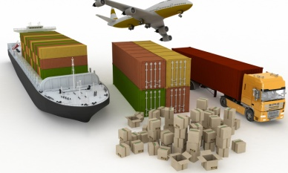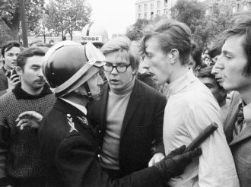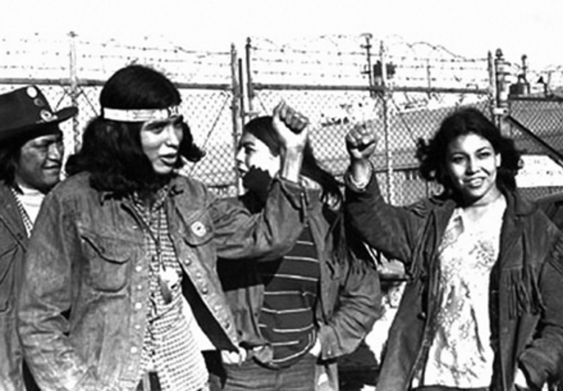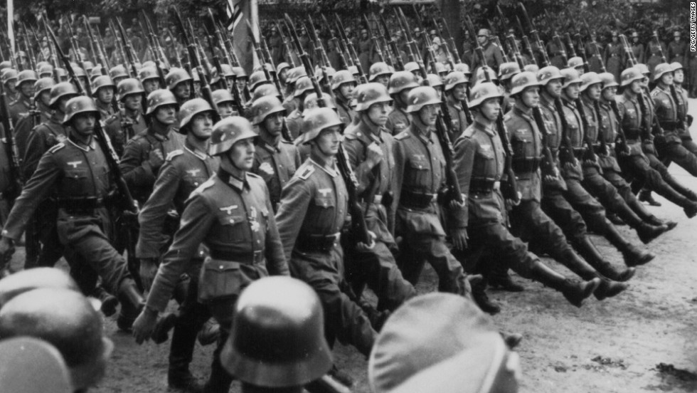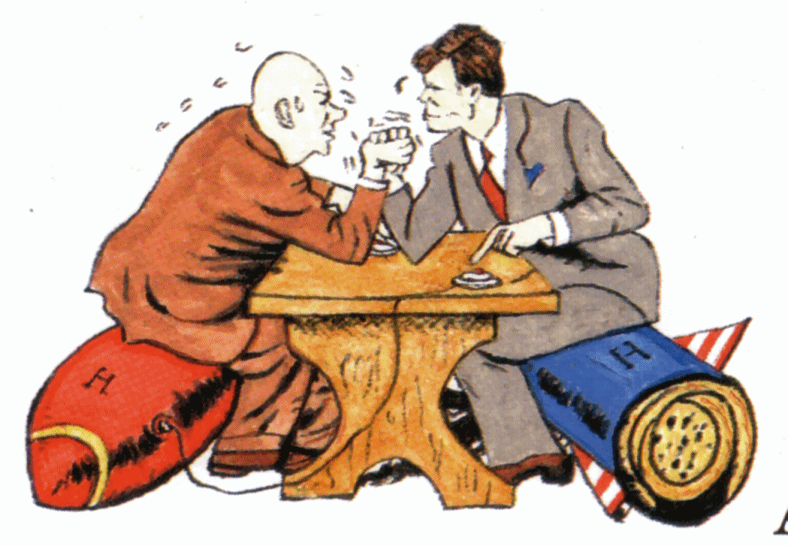

[scaffoldingmagic.com](https://scaffoldingmagic.com/)

A. *Translate:*:

crowd _______________ custom duties _______________

surplus _______________ riot _______________

1. The 1960s sees the emergence of 'youth culture', with groups such as The Beatles attracting huge crowds of teenage fans wherever they appear, helping to stimulate a cultural revolution and widening the generation gap.
2. It is a good period for the economy, helped by the fact that the EU countries stop charging custom duties when they trade with each other.
3. They also agree joint control over food production, so that everybody now has enough to eat - and soon there is even a surplus agricultural produce.
4. May 1968 becomes famous for student riots in Paris and many changes in society and behaviour become associated with the so-called '68 generation.

B. Create a drum rhythm for one of the above sentences:

C. Write the number of the sentence that best represents image below

___ ___ ___ ___

*A. Translate*:

raise _______________ poor _______________

overthrow _______________ increase _______________

1. Denmark, Ireland and the United Kingdom join the European Union on 1 January 1973, raising the number of member states to nine. The short, yet brutal, Arab-Israeli war of October 1973 results in an energy crises and economic problems in Europe.
2. The last right-wing dictatorships in Europe come to an end with the overthrow of the Salazar regime in Portugal in 1974 and the death of General Franco in Spain in 1975.
3. The EU regional policy starts to transfer huge sums to create jobs and infrastructure in poorer areas.
4. The European Parliament increases its influence in EU affairs and in 1979 all citizens can, for the first time, elect their members directly.

B. Create a drum rhythm for one of the above sentences:

C. Write the number of the sentence that best represents image below.

___ ___ ___ ___

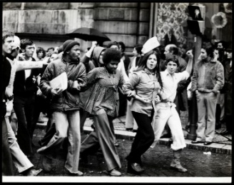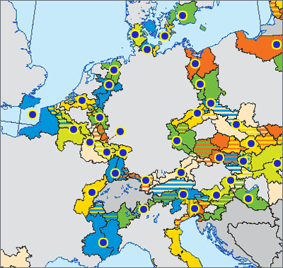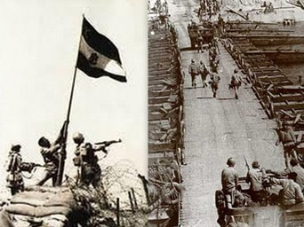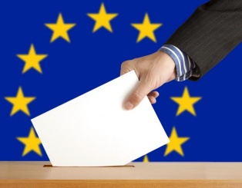

A. *Translate:*

strike _______________ upheaval _______________

treaty _______________ fall _______________

1. The Polish trade union, Solidarnosc, and its leader Lech Walesa, become household names across Europe and the world following the Gdansk shipyard strikes in the summer of 1980.
2. In 1981, Greece becomes the 10th member of the EU and Spain and Portugal follow five years later. In 1986, the Single European Act is signed. This is a treaty which provides the basis for a vast six-year programme aimed at sorting out the problems with the free-flow of trade across the EU borders and thus creates the 'Single Market'.
3. There is a political upheaval when, on 9 November 1989, the Berlin Wall is pulled down and the border between East and West Germany is opened for the first time in 28 years.
4. The fall of the Berlin Wall leads to the reunification of Germany when both East and West Germany are united in October 1990.

B. Create a drum rhythm for one of the above sentences:

C. Write the number of the sentence that best represents image below

___ ___ ___ ___

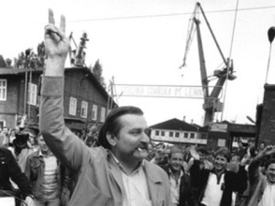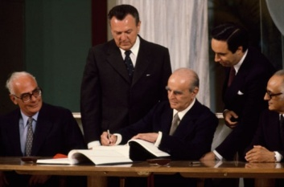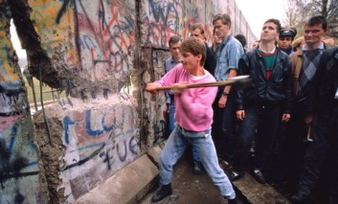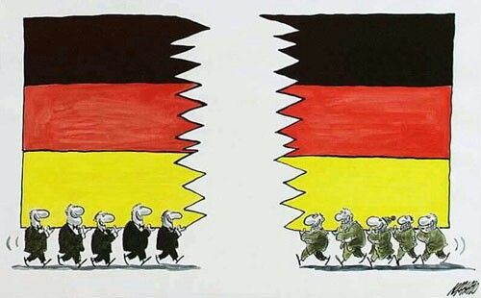

[scaffoldingmagic.com](https://scaffoldingmagic.com/)

***LOWER AND HIGHER-ORDER THINKING QUESTIONS:***

a. Which sentence refers to a condition of rivalry, mistrust, and often open hostility short of violence especially between power groups (such as labor and management)?

b. Which sentence refers to a situation in which taxes are levied on imports (and, sometimes, on exports) by the customs authorities of a country to raise state revenue, and/or to protect domestic industries from more efficient or predatory competitors from abroad?

c. Where can you find a reference to people bringing about the downfall, destruction or ending of, especially by force or concerted action of a country?

d. Where do you find information about an electrician - who later became president of the country - who was fundamental in the negotiations between shipyard workers and the government?

[scaffoldingmagic.com](https://scaffoldingmagic.com/)

e. How successful has the European Union been in creating a balanced economic system?

f. How much did the fall of the Berlin Wall affect stability in Europe?

Etc.