

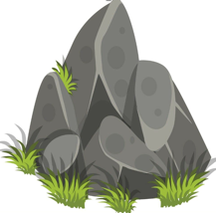
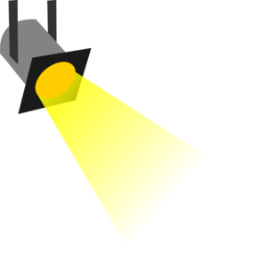

______________ __________________ _________________ _______________

- Write the appropriate term under the images above.

- Take turns with your partner repeating the sentences aloud. (Download audio of sentences here.)

- The moon is a sphere and smaller than the Earth
- The Moon is made of rock.
- There is no water or air on the Moon.
- The Moon moves around the Earth.
- The Moon and the Earth move around the Sun.
- The Sun gives light to the Moon.

- With your partner, create a drum rhythm for each of the sentences. (Download audio examples of rhythm here.)

- The moon is a sphere and smaller than the Earth
- The Moon is made of rock.
- There is no water or air on the Moon.

- Record your group saying the sentences with the rhythm you've created.

- High-Order Thinking Questions:
- Why is there no water or air on the Moon?
- How does the Sun give light to the Moon?
- What if the Earth moved around the Moon?

