**Scaffolding Reported Speech in Context**

***Handout***

[*The Black Hand Gang and the Mysterious House*](https://www.amazon.es/Black-Hand-Gang-Mysterious-House/dp/3473520667/ref=sr_1_1?__mk_es_ES=%C3%85M%C3%85%C5%BD%C3%95%C3%91&crid=1XR4ID7P5Y9L2&keywords=the+black+hand+gang+and+the+mysterious+house&qid=1642607226&sprefix=the+black+hand+gang+and+the+myserious+house%2Caps%2C300&sr=8-1)

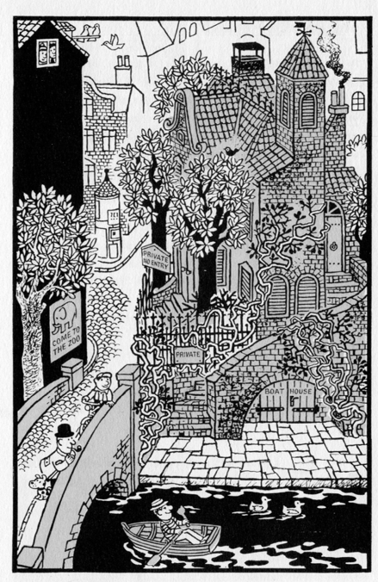

* Describe what you see.
* If someone asked you if someone lives in the house, what would you say?
* What do you think the man on the bridge and the man in the boat are thinking?

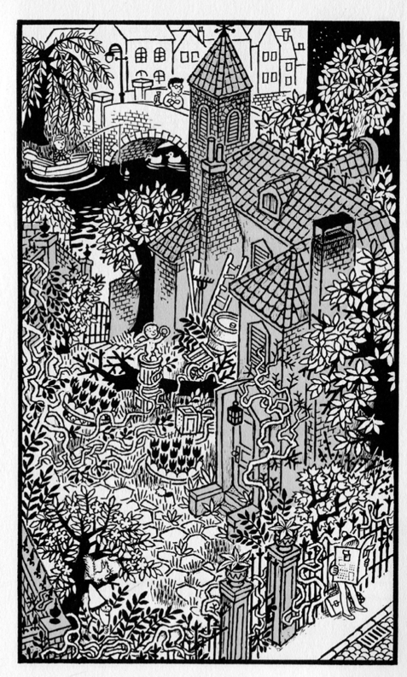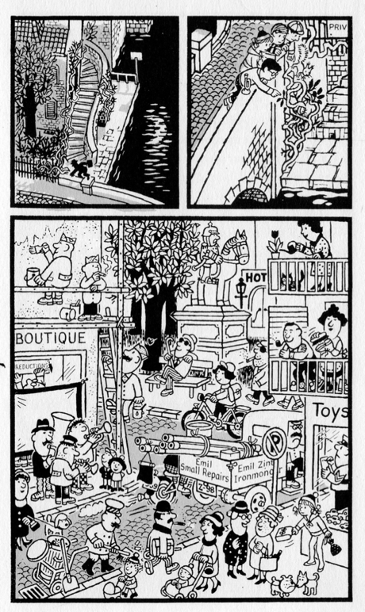

* Describe what you see?
* What do you think the boy on the bridge is looking for?
* Can you find the hidden door to enter the house?
* Describe what you see
* What do you think the four children are looking at under the bridge?
* Can you find a man without a shoe in the bottom picture?

**Step by step:**

1. Read the following statements to your partner.
2. Listen to your partner change the statements to Reported Speech.
3. Ask your partner which word is inaccurate
4. If you agree, write the inaccurate word in the right-hand column.
5. Repeat with your partner beginning.

***EXAMPLE***:

STUDENT 1

|  |  |  |  |
| --- | --- | --- | --- |
|  | Statements to Read and  Your Partner Repeats in Reported Speech | Inaccurate Word/s | Accurate Word |
|  | Ralph: ‘Someone lives in that house. I see water in the chimney.’ |  |  |

STUDENT 2

|  |  |  |  |
| --- | --- | --- | --- |
|  | Statements to Read and  Your Partner Repeats in Reported Speech | Inaccurate Word/s | Accurate Word |
|  | Susan: ‘My uncle is on a boat in the river. He is passing over the bridge.’ |  |  |

*Example:*

Student 1: Ralph: ‘Someone lives in that house. I see water in the chimney.’

Student 2: Ralph said that that someone lived in that house. He saw water in the chimney.’

Student 1: Which word is inaccurate?

Student 2: I don’t think water comes out of a chimney. I think it makes more sense that smoke comes out of a chimney.

Student 1: Yes, that makes more sense. I’ll need to write ‘water’ in ‘inaccurate’ column and ‘smoke’ in the ‘accurate’ column. Now it’s your turn.

Student 2: Susan: ‘My uncle is on a boat in the river. He is passing over the bridge.’

Student 1: Susan said that her uncle was on a boat in the river. He was passing over the bridge.

Etc.

*Phrases to help to move conversation forward:*

*That’s more accurate.*

*It makes sense because...*

*It doesn't make sense because...*

*I think...*

*What do you think about....?*

*I don't think __________ makes sense.*

*Which word....?*

*It’s your turn now.*