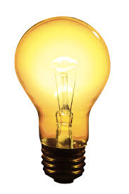
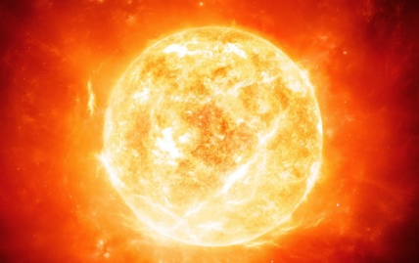
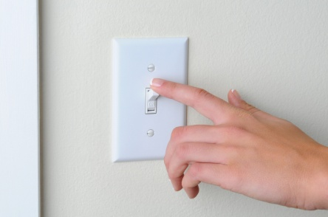
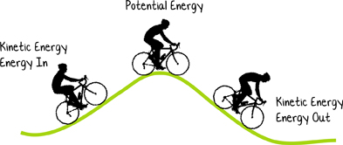
non-living
switch
kinetic

noise
thermal
bulb
ACADEMIC TERM | TERM USED IN SENTENCES | OUR DEFINITION OF THE TERM | STANDARD DEFINTION OF THE TERM  (How close were we?!)
bulb | When I turn on the switch, the bulb lights up. | A bulb is an object that projects light when it is charged with electricity.
kinetic | A bird flying shows kinetic energy.
noise | The band made a lot of noise outside my bedroom.
non-living | Plates are non-living things.
switch | To turn on the light, I need to find the switch.
thermal | The sun is one type of thermal energy.

